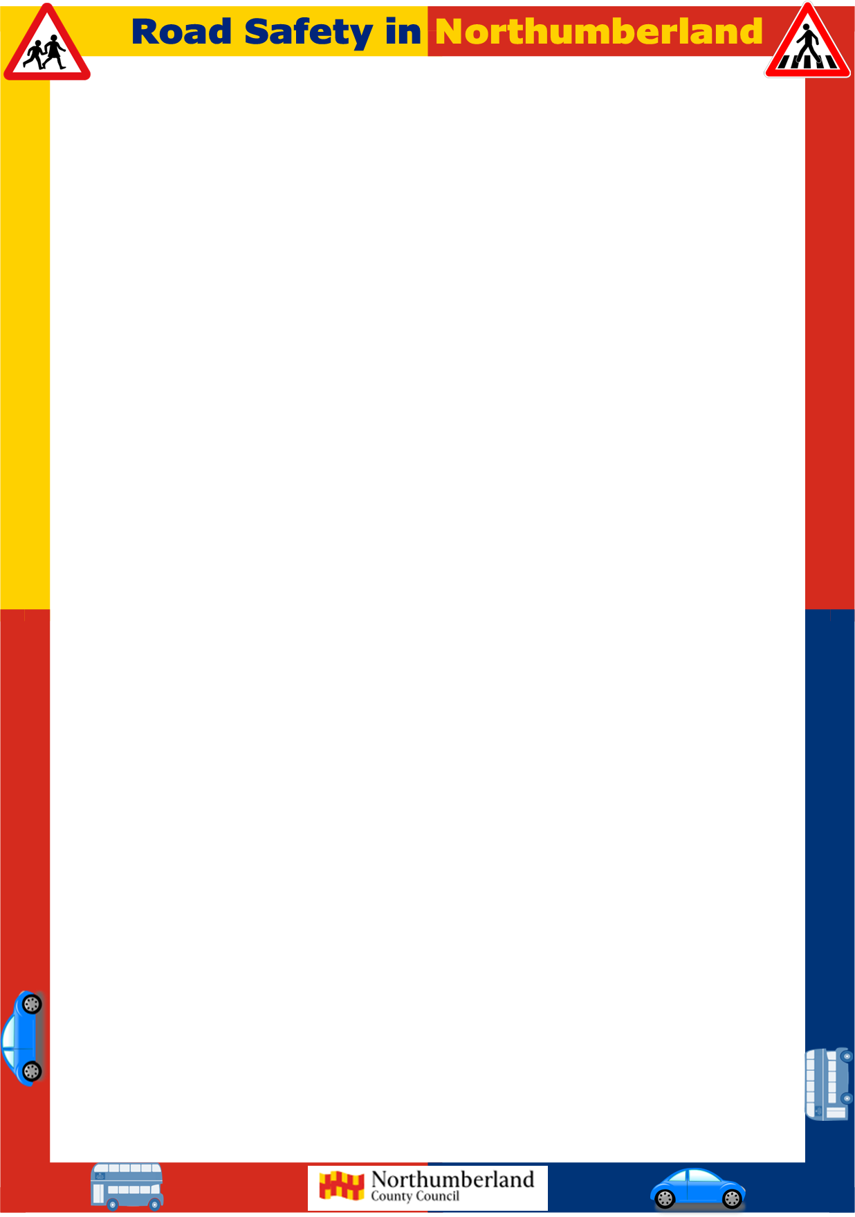
Green Cross Code
- What are the 4 sequences of the Green Cross Code? Write them in the correct order.
Answer:

- Listen: What traffic sounds can you hear?
Answer:

- Which traffic sound should not be on the road?
Answer:
- At a light crossing, even though the green man is showing, and traffic has stopped. What vehicle noise would stop you crossing the road?​
Answer:

Write some tips on the worksheet to help you remember what to do when crossing the road.​ For example, where do you stop? Which direction do you look first? What should you do when you are walking across the road?

